**T.C**

**KARABUK UNİVERSITY ENGINEERING FACULTY COMPUTER ENGINEERING**



**VISUAL PROGRAMMING**

**PROJECT TASK**

**CINEMA AUTOMATION**

**PROJECT OWNER**

2010213027 İLYAS EFE SARISÜLEYMAN

**Table of Contents**

1. Introduction 3
2. Login and Register Page 4
3. Personal Management System Page 5
4. Record a new employee 5
5. Deleting Personal 6
6. Searching Personal 8
7. Chart Graphic Page 9
8. ***INTRODUCTION***

In this project main task is personal management system, manages and displays an employee. In the first page there are sign in (login) and sing up (register) pages. Second page is about management of employees, I mean delete an employee, record a new employee and search by full name the employee also there are some things in this page. In third page we can see the chart graphic about some companies. It demonstrates that in which company how many men and woman works. Also, in this page we can go back page and first page etc.

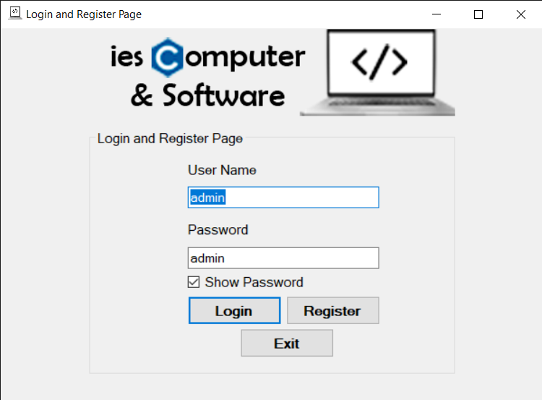

In this is first page firstly you can register (sign up) the system. If it is everything ok. The message below will appear on the screen.

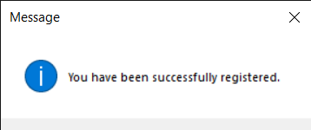

After that this message you can close the message then you can log in to the system by typing your information with click login button.

When you log in to the system you will see below page. This is the second page we are seeing. Actually, this page is for management the employee’s information system. You can delete the personal, you can save or record a new employee. Also, you can search the personal with only its full name by writing full name in full name textbox.

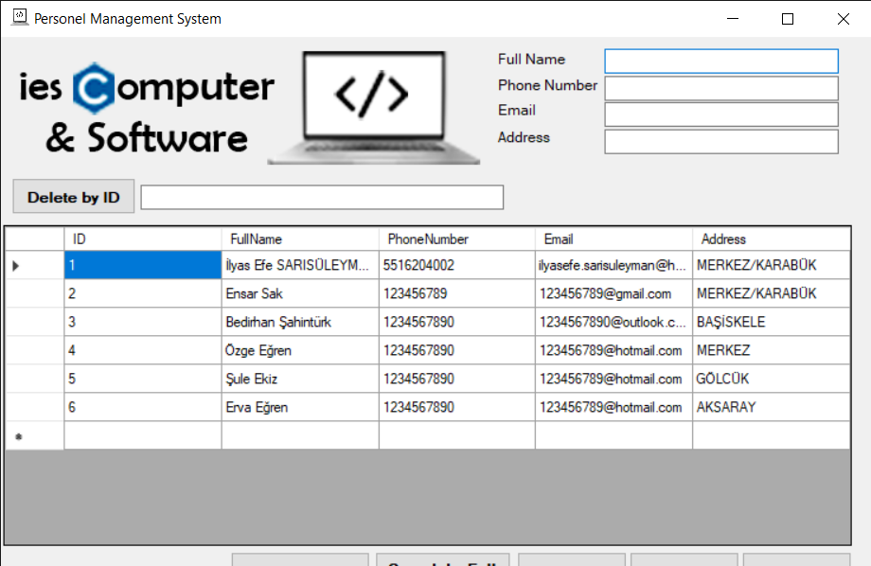

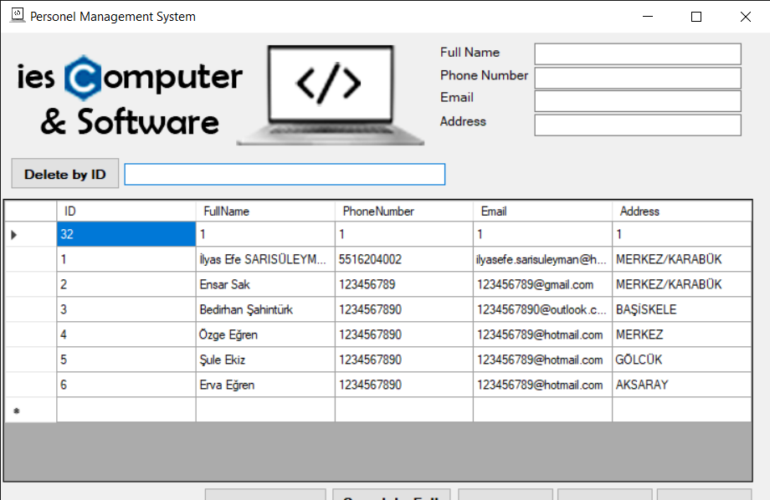

If there is unwanted information in the table, for example first row ID is 32 we can delete it. If you write its ID number and click the button that Delete by ID then that personal will delete in this system.

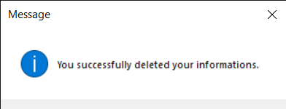

After that click the button this message will appear. This message is saying that you successfully deleted its information. I mean you deleted that person, employees or personal successfully in this system.

In this picture showing us successfully deleted. Because we don’t see any unwanted information. Like previous one.

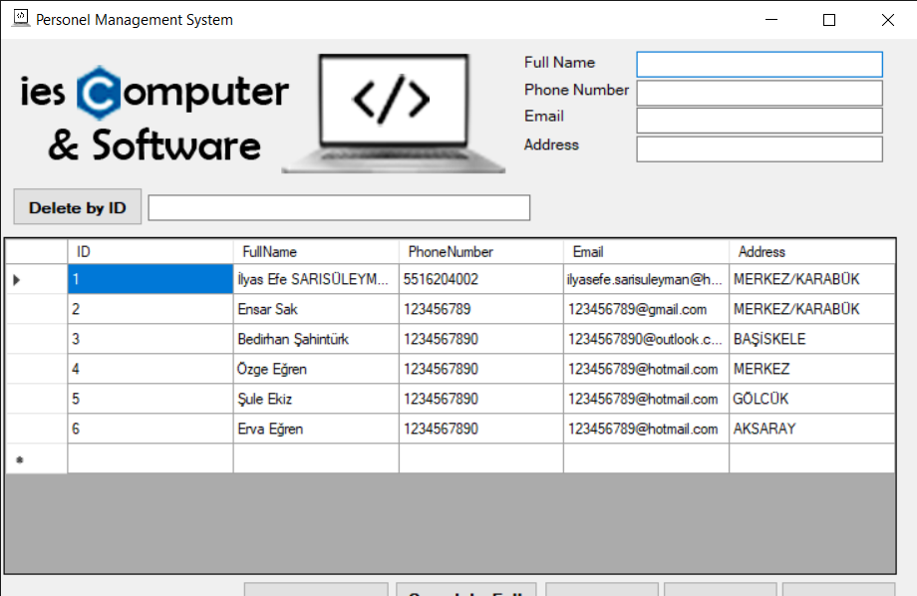

If you want to search someone in this sytem you have to write its name and you must click the search by full name button. Then like this picture appear on the screen. You will find the personal in the system. Also you can delete with this method. Firstly you can find then you can delete it.

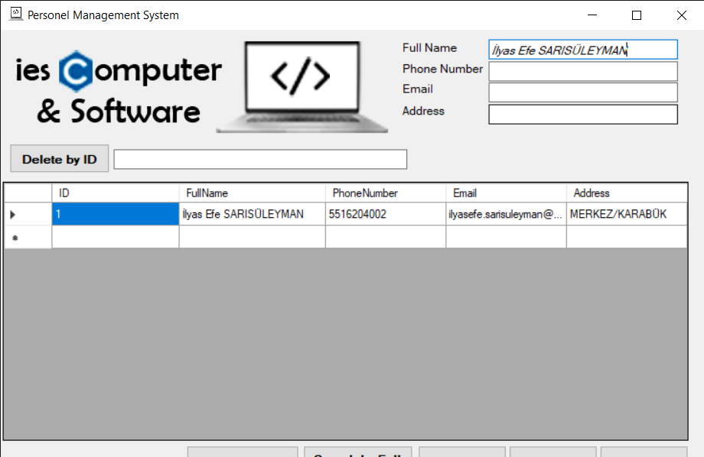

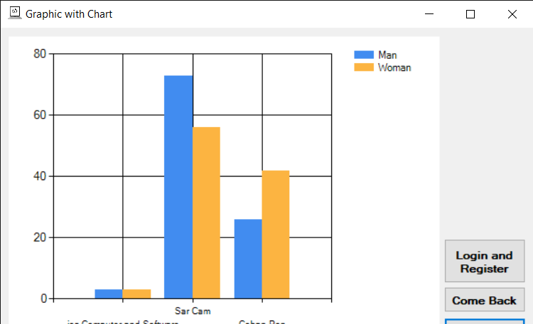

In this third page you can see this chart graphic. It demonstrates us how many men and woman working in these companies. For example, in our company. Or you can develop this system graphic.